Steps to Create Docker RabbitMQ Image using DevOps (Ansible script)

1. **On local server, Download the official docker image of RabbitMQ from rabbitmq/official**



1. **Followed by local image creation:**



Or just use



1. **Create the Dockerfile for the purpose of DevOps deployment:**

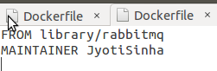

Official repository for rabbitmq used during ‘image pull’ on local server

1. **Build Ansible host file to list out the servers to be deployed with same image:**

Cd to ansible folder:

$ cd /etc/ansible

Change the *host* file

Make sure to back-up the existing *hosts* file as *hosts-backup*

 mv hosts hosts-backup

Edit the *hosts* file as following:



Remove all the entries from *hosts* file and modified *hosts* file looks like as following:

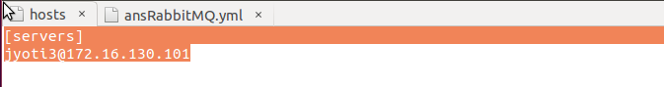

1. **Create Ansible Playbook now,**

Change directory to Ansible folder

$ cd /etc/ansible

Jyoti2@jyoti2-VirtualBox:/etc/ansible$ sudo gedit ansRabbitMQ.yml

In the gedit text editor, make following changes and hit ‘Save’

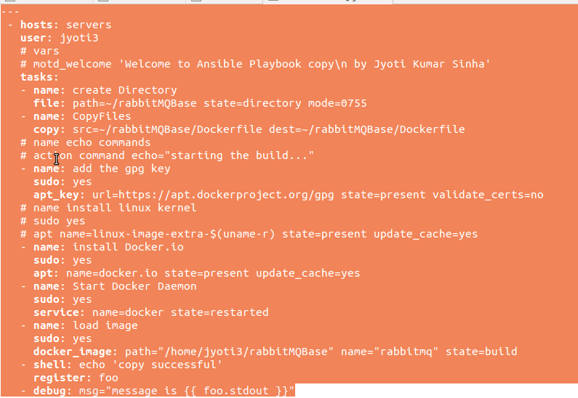

Module to add “sudo” privilege to task

Path on “Remote machine” where Dockerfile is copied from local server

Copy the Dockerfile from “local server” to “remote server”

1. **Now, go over to command prompt, and run the playbook:**



--step will prompt for each step execution with user choices (y=Yes, n=No, c=Continue without asking anymore)

-K will prompt user for sudo password, in case sudo is used inside Ansible playbook (as is in the case of current playbook)

Output of above execution shall be similar to following:

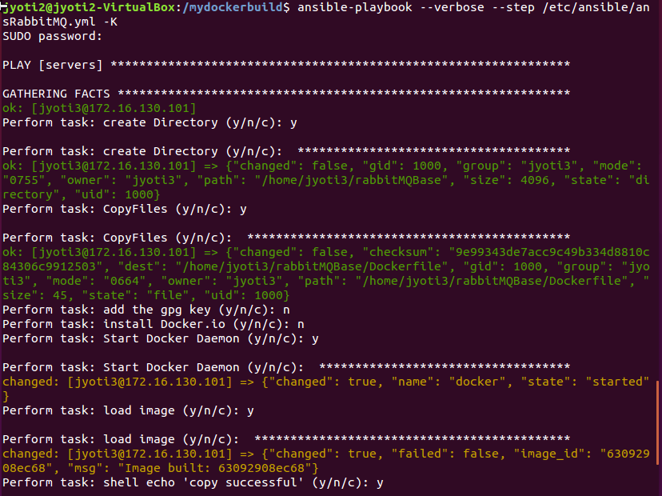

1. **Verify the image deployment:**

Login to remote machine(or ssh)

And try following:



Output should be similar to following:

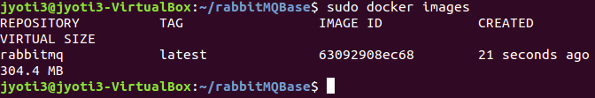

Try to check the docker log for rabbitmq



Output shall be a detailed info something like following:

